

River Habitat Enhancement Workshop

Friday, October 3rd, at 9:30 am

at Langford Lakes Nature Reserve, Steeple Langford, Wiltshire

Draft Programme

9:00 Arrive at Langford Lakes

9:30 Introduction to STREAM and river restoration

10:00 River restoration and
- SSSI favourable condition/good ecological status
- the planning process, inc. Environmental Impact Assessment

11:00 Site visit, River Wylye at Chilhampton (transport provided)

12:45 Lunch (provided)

13:30 Site visit, Fovant (transport provided)

15:30 Coaches return to Langford

15:45 Discussion (participants suggest topics on the day)

16:30 Close


The STREAM project is supported financially by the European LIFE Nature fund. The project partners are Natural England, the Environment Agency, Wiltshire Wildlife Trust, Hampshire and the Isle of Wight Wildlife Trust and Wessex Water.

Getting there:
By bus: Wilts and Dorset and Badgerline buses stop at Steeple Langford. Hourly bus (X4, X5, X6), Monday to Saturdays, 7am – 6.00pm. Short walk from the bus stop to nature reserve along Duck Street.
By car: Just off the A36 Salisbury to Warminster road – take sign for The Langfords. In Steeple Langford turn into Duck Street. Nature reserve entrance is on the left-hand side, once you have crossed the river. Where possible, please consider car sharing with others attending.

Bicycle: Langford lakes is close to the Wiltshire Cycleway and the National Byway network

General Map

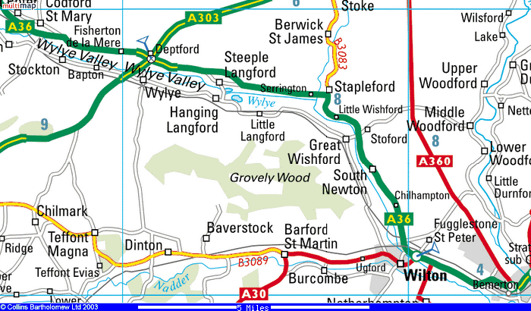
Detailed map



