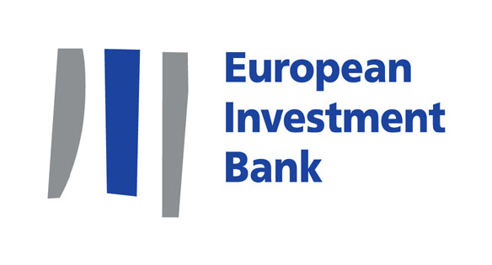

PRESS RELEASE

2010-223-EN

6 December 2010

EUR 55 million boost for water in North-Western Syria

- Focuses on the development of modern water supply, wastewater collection and treatment
- Improves the quality of life of 374 000 inhabitants of more than 200 villages
- Expected to create 200 new employment opportunities

Today, the European Investment Bank’s Vice-President, Philippe de Fontaine Vive, and the Syrian Minister of Housing and Construction, Dr. Omar Ghalawanji, signed a EUR 55m finance agreement for the development of modern water supply, wastewater collection and treatment infrastructure in North-Western Syria.

The project is part of the EU Horizon 2020 initiative, one of the priorities of the Union for the Mediterranean (UfM), which aims to tackle major sources of Mediterranean pollution by 2020.

The operation will improve water and wastewater services for over 370 000 inhabitants of 200 villages and will strengthen environmental sustainability by reducing wastewater discharges into the Mediterranean Sea. The area concerned includes the city of Banias and surrounding villages, and villages of the four river catchments of Hreisun, Jobar, Al Ghamkah and Al Dabousiah draining into the Mediterranean Sea. It will contribute to:

- Water Supply: rehabilitation and upgrading of existing infrastructure for ground water extraction, particularly in the Banias catchment area, where it is envisaged to reduce leakage levels from the current 70% to 40% in the coming years.
- Wastewater collection: development and upgrading of separate systems for domestic wastewater and stormwater.
- Wastewater Treatment plants (WWTPs): construction of one common wastewater treatment plant for the town of Banias and the two river basins of Hreisun and Jobar, and construction of an additional six wastewater treatment plants in Al Dabousiah and Al Ghamkah.

Philippe de Fontaine Vive, European Investment Bank Vice-President responsible for FEMIP – the Facility for Euro-Mediterranean Investment and Partnership – commented: “I am particularly proud of both the “green” footprint of this project, which is included in the EU Horizon 2020 initiative aimed at fighting pollution in the Mediterranean sea, and its positive impact on the quality of life and welfare of many inhabitants in this part of Syria through the development of modern water supply, wastewater collection and treatment systems”.

This project provides an important response to the crucial challenge of water management in Syria resulting from high population growth, increasing urbanization, economic development and the reduction of rainfall observed over the last decade. It meets one of the priorities of the Union for the Mediterranean (UfM): cleaning-up the Mediterranean Sea. It also serves the objectives of Syria’s five-year plan, which sets out the government’s investment priorities for this sector to improve access to water and sanitation for the population as a whole, as well as the efficiency and management of the sector.
Press contact:
Anne Cécile Auguin, a.auguin@eib.org, +352 43 79 83330 / +352 621 36 19 48
Website: www.eib.org/press - Press desk: +352 4379 21000 – press@eib.org

